LINGAYAS INSTITUTE OF MANAGEMENT AND TECHNOLOGY
(Autonomous)
Approved by AICTE, New Delhi and Permanently Affiliated to JNTUK, Kakinada
Accredited by NAAC with “A” Grade | UG-CSE Accredited by NBA
Madalavarigudem, Vijayawada - 521212, Andhra Pradesh

Mean Stack Web Technologies
Mini Project Report

SMART CITY RESCUE

A mini report submitted in partial fulfilment of the academic requirements of the Mini Project
for the award of the degree of
BACHELOR OF TECHNOLOGY

Submitted by
Student Name | Hall Ticket No. | Department
A. Geethika | 23NA1A5424 | AI&DS
P. Mounica | 23NA1A5430 | AI&DS


Under the Esteemed Guidance of
Prof. B. Pavan Akhil, M.Tech

DEPARTMENT OF
ARTIFICIAL INTELLIGENCE AND DATA SCIENCE
Lingayas Institute of Management and Technology

IV-I SEMESTER
ACADEMIC YEAR 2026-27

DECLARATION
We, A. Geethika[23NA1A5424] and P. Mounica[23NA1A5430], hereby declare that this mini project report titled “Smart City Rescue” is our original work carried out under the guidance of B. Pavan Akhil, M.Tech, Department of Artificial Intelligence and Data Science. The work presented in this report has not been submitted to any other institution or agency for the award of any degree, diploma, or certification. All sources of information used in this report have been properly acknowledged.
We further declare that the project work, documentation, screenshots, datasets, code, designs, diagrams, and references included in this report are prepared with academic honesty and are presented to the best of our knowledge.
Place: Vijayawada
Date: [DD/MM/YYYY]

Signature of Students
Geethika A-23NA1A5424
Monica P-23NA1A5430

CERTIFICATE
This is to certify that the mini project report entitled “SMART CITY RESCUE” is the bona fide work carried out by A. Geethika [23NA1A5424], P. Mounica [23NA1A5430] in partial fulfillment of the requirements for the award of the Degree of Bachelor of Technology in Artificial Intelligence and Data Science. during the academic year 2026-27 at Lingayas Institute of Management and Technology, Vijayawada, under the guidance of B. Pavan Akhil, M. Tech.
The work has been reviewed and found suitable for submission as an mini project report.

____________________________ | ____________________________ | ____________________________
PROJECT GUIDE  [Name of Faculty Guide] | HEAD OF THE DEPARTMENT  [Name of HoD] | EXTERNAL EXAMINER

ACKNOWLEDGEMENTS
I would like to articulate my profound gratitude and indebtedness to my guide Assistant Professor, B. Pavan Akhil, department of Computer Science and Engineering, who has always been a constant motivation and driving force throughout the project time in and out as well. It has been a great pleasure for me to get an opportunity to work under her/his guidance and complete the project successfully.
I would like to thank Head of the Department, B. Lakshmi computer science engineering of Lingayas Institute of Management and Technology for consistently supporting my work throughout the project period with all patience and understanding, giving valuable inputs whenever required for betterment of the work.
I would like to express my gratitude to Mentor G.Bhanu Prakash department of Computer Science and Engineering
I would like to express my gratitude to all the department faculty, department of computer science and engineering for supporting us in all aspects.
I also express my gratitude to our Principal, for his encouragement and facilities provided during the course of project.
I would like to articulate our beloved Chairman, Mr. Rajling Gadde sir for his great motivation and encouragement towards project work.
I am grateful to other staff members of department of computer science engineering and the institute for co-operating with me throughout my project.
I thank all my friends and batchmates who were with me during thick and thin of project time and were great support throughout the undergraduate period.

Yours sincerely,
A. Geethika-23NA1A5424
P. Mounica-23NA1A5430

ABSTRACT
Smart City Rescue is an interactive game application designed to create awareness about smart cities and common urban problems through an engaging and educational gaming experience. The game places the player in a virtual city where they take the role of a rescue character and complete different missions related to city management, safety, cleanliness, traffic, energy, and other urban challenges.

The game includes features such as a city map, missions, rescue activities, player profile, leaderboard, rewards, levels, and progress tracking. Players earn points, stars, and coins by successfully completing missions and solving different problems in the city. This makes the learning process more interactive and encourages players to improve their problem-solving skills.

The application is developed using modern technologies such as React.js for the frontend, Node.js and Express.js for the backend, and MongoDB for data storage. An AI/ML module can be used to analyse player performance, understand their progress, predict suitable difficulty levels, and provide smart mission recommendations.

The main goal of Smart City Rescue is to combine education, problem-solving, and gamification to help users understand urban challenges in an interesting and practical way. The project aims to provide an interactive platform where players can learn about smart city concepts while completing rescue missions and working towards building a better virtual city.

CONTENTS
Sessions | Pages
Declaration | 2
Certificate | 3
Acknowledgement | 4
Abstract | 5
Contents | 6
Chapter 1 INTRODUCTION | 7-8
Chapter 2 LITERATURE REVIEW | 9-10
Chapter 3 REQUIREMENTS, METHODOLOGY AND SYSTEM DESIGN | 11-14
Chapter 4 IMPLEMENTATION, TESTING AND RESULTS | 15-18
Chapter 5 CONCLUSION AND FUTURE SCOPE | 19-20

CHAPTER 1
INTRODUCTION

1.1 Introduction
Smart cities use technology to improve the quality of life, safety, cleanliness, transportation, and management of urban areas. However, many people, especially young students, may not be aware of how common city problems can affect the environment and public life.
Smart City Rescue is an interactive game-based application designed to create awareness about common urban problems through an engaging gaming experience. In the game, the player acts as a Smart City Rescue Officer and is given different missions related to city problems such as garbage accumulation, broken street lights, water leakage, damaged roads, traffic problems, drainage issues, and emergency situations.
Instead of simply providing information, the system allows users to learn by performing actions inside the virtual city. Players complete missions, earn coins and experience points, unlock achievements, and improve the virtual city.

1.2 Problem Statement
Urban areas face several problems such as improper waste disposal, water wastage, damaged roads, traffic congestion, and insufficient public awareness. Traditional awareness methods such as posters, notices, and text-based information may not always provide an engaging learning experience.
Therefore, there is a need for an interactive system that can educate users about urban problems while keeping them engaged. Smart City Rescue addresses this requirement by converting common city problems into interactive game missions.

1.3 Objectives
The main objectives of the Smart City Rescue project are:
- To create an interactive smart-city themed game.
- To increase awareness of common urban problems.
- To provide problem-solving missions through mini-games.
- To encourage users to complete environmental and civic tasks.
- To maintain player scores, XP, coins, achievements, and progress.
- To provide a leaderboard for competitive gameplay.
- To visually show the improvement of the virtual city.
- To provide an enjoyable and educational gaming experience.

1.4 Scope of the Project
The project focuses on creating a virtual city where players can identify and solve different problems. The system can be extended in the future with more city locations, advanced missions, artificial intelligence, multiplayer functionality, real-time data, and additional educational content.

1.5 Overview of the Proposed System
The proposed system consists of a home screen, city map, mission selection, gameplay screens, player profile, leaderboard, rewards, achievements, and analytics. Players can select missions from the city map and complete them within a specified time. The system calculates the score and rewards based on the player's performance.

CHAPTER 2
LITERATURE REVIEW

2.1 Introduction
This chapter discusses existing approaches related to smart-city awareness, educational applications, and game-based learning. These approaches provide useful ideas for designing an interactive system that combines learning and entertainment.

2.2 Smart City Applications
Smart city applications generally use digital technologies to improve urban services. Common areas include waste management, transportation, water management, public safety, energy management, and environmental monitoring.
These applications demonstrate how technology can be used to identify and manage problems in urban environments.

2.3 Game-Based Learning
Game-based learning uses game elements to make learning more interactive. Players can learn concepts by completing challenges, solving problems, earning rewards, and progressing through levels.
The Smart City Rescue project applies this concept to civic and environmental awareness.

2.4 Existing System
Existing awareness systems generally provide information through websites, mobile applications, educational content, or notification systems. Although these systems can provide useful information, they may not provide an interactive gaming experience.
2.5 Limitations of Existing Approaches
Some common limitations include:
- Limited user interaction.
- Less motivation for continuous participation.
- Mostly information-based interfaces.
- Lack of game-based rewards.
- Limited visualization of city improvement.
- Less emphasis on problem-solving activities.
2.6 Proposed System
Smart City Rescue combines smart-city concepts with game mechanics. Instead of only reading about city problems, users interact with them through missions and mini-games.
The proposed system provides:
- Interactive missions.
- Multiple problem categories.
- Scores and rewards.
- XP and level progression.
- Achievements.
- Leaderboard.
- City progress.
- Player analytics.

CHAPTER 3
REQUIREMENTS, METHODOLOGY AND SYSTEM DESIGN

3.1 Introduction
This chapter explains the requirements, development methodology, technologies, system architecture, modules, and database design of Smart City Rescue.

3.2 Functional Requirements
The system should provide the following functions:
1. User registration and login.
2. Player profile management.
3. Interactive city map.
4. Mission selection.
5. Mission gameplay.
6. Score calculation.
7. Coins and XP management.
8. Achievement management.
9. Leaderboard.
10. Daily rewards.
11. City progress tracking.
12. Player performance information.

3.3 Non-Functional Requirements
The system should be:
- User-friendly.
- Responsive.
- Reliable.
- Easy to navigate.
- Interactive.
- Secure.
- Maintainable.
- Suitable for desktop and mobile screens.

3.4 Technology Used
The major technologies and tools used in the project include:
- Base44 – application development and interface creation.
- Database/Backend services – storing player and game information.
- HTML/CSS/JavaScript concepts – for web-based interaction where applicable.
- AI/ML integration – optional future or supporting functionality.
- Browser – for running and testing the application.

3.5 System Architecture

The user interacts with the Smart City Rescue interface. The application processes user actions and communicates with the backend/database to store player information, mission progress, scores, rewards, and achievements.

3.6 Major Modules
3.6.1 User Authentication
This module allows users to register, log in, and access their personal game profile.
3.6.2 Home Module
The home screen provides access to Play, Missions, Leaderboard, Settings, Profile, Shop, Daily Rewards, and Achievements.
3.6.3 City Map Module
The city map displays different problem locations using different markers. Players can select a location to view the available mission.
3.6.4 Mission Module
The mission module provides different challenges such as garbage collection, street-light repair, water-leakage control, road repair, and traffic management.
3.6.5 Reward Module
Players receive coins, XP, stars, and rescue points after completing missions.
3.6.6 Leaderboard Module
The leaderboard displays player rankings based on their scores.
3.6.7 Achievement Module
Players unlock achievements after completing specific objectives.
3.7 Game Flow
Login → Home → City Map → Select Mission → Start Mission → Complete Challenge → Calculate Score → Receive Reward → Update Progress → Continue to Next Mission

3.8 Database Design
The system stores information related to users, missions, player progress, achievements, leaderboard information, and daily rewards.
Important data fields include:
- Users: name, email, level, XP, coins, score.
- Missions: title, category, difficulty, reward, XP, time limit.
- Player Progress: user ID, mission ID, score, stars, completion status, time taken.
- Achievements: achievement name, description, requirement, reward.

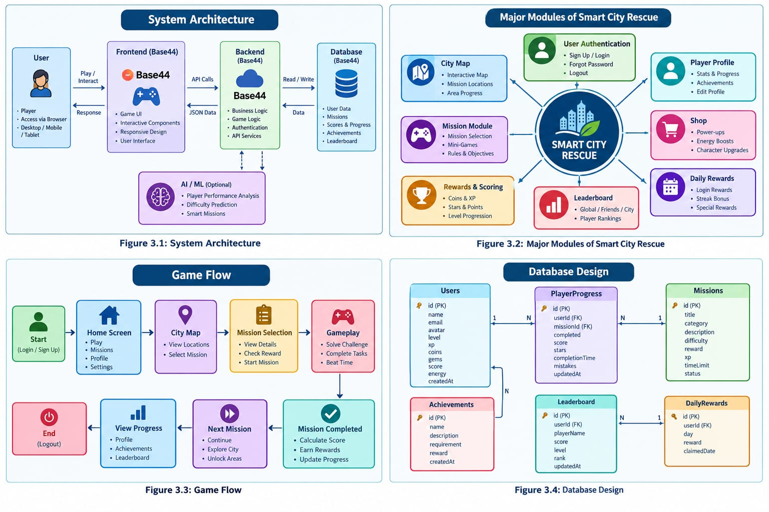

CHAPTER 4
IMPLEMENTATION, TESTING AND RESULTS

4.1 Introduction
This chapter describes the implementation of the Smart City Rescue application and the testing performed to verify the functionality of the system.
4.2 Home Screen Implementation
The home screen provides the main navigation options. The player can start the game, view missions, access the leaderboard, open the profile, view achievements, and access settings.
4.3 City Map Implementation
The city map provides an interactive representation of the virtual city. Different markers represent different types of problems. Selecting a marker opens the corresponding mission.
4.4 Mission Implementation
The game contains multiple missions. Each mission has an objective, difficulty level, time limit, reward, and completion condition.
Examples include:
- Garbage Collection
- Street Light Repair
- Water Leakage
- Road Damage
- Traffic Management
- Emergency Rescue

4.5 Scoring and Reward Implementation
The system calculates the player's performance based on successful actions, completion time, and mistakes. The player receives coins, XP, points, and stars after completing a mission.
4.6 Player Profile
The profile displays the player's level, XP, score, completed missions, coins, and achievements.
4.7 Leaderboard
The leaderboard provides a ranking of players according to their scores. It encourages users to complete more missions and improve their performance.
4.8 Testing
Testing is performed to verify that the major features work correctly.
Test Case | Expected Result | Status
User Login | User enters the game successfully | Pass
Open City Map | City map is displayed | Pass
Select Mission | Mission details are displayed | Pass
Start Mission| | Game play starts | Pass
Complete Mission | Score and rewards are generated | Pass
Open Profile | Player information is displayed | Pass
Open Leaderboard | Player rankings are displayed | Pass

4.9 Results
The implemented system provides an interactive gaming environment where users can explore a virtual city and solve different problems. The game successfully combines city awareness with entertainment through missions, rewards, achievements, and progress tracking.
The application provides a simple and engaging interface suitable for demonstrating smart-city concepts through game-based interaction.
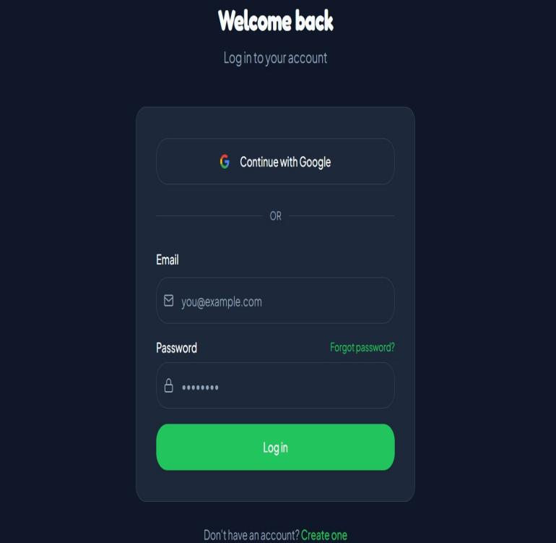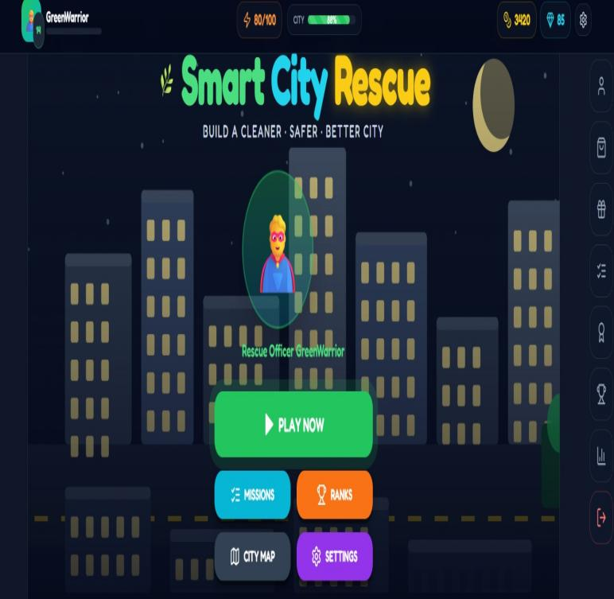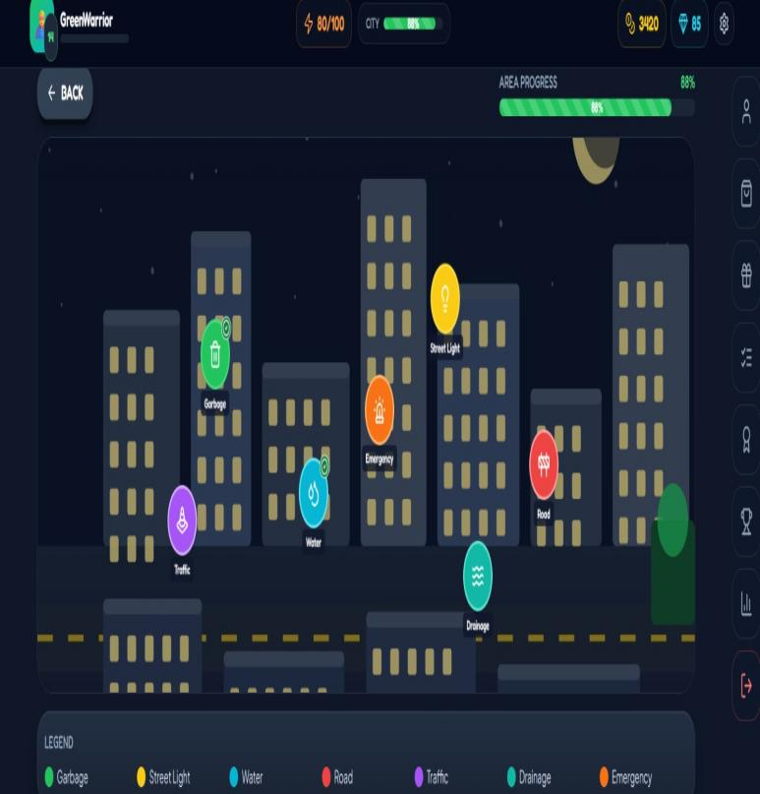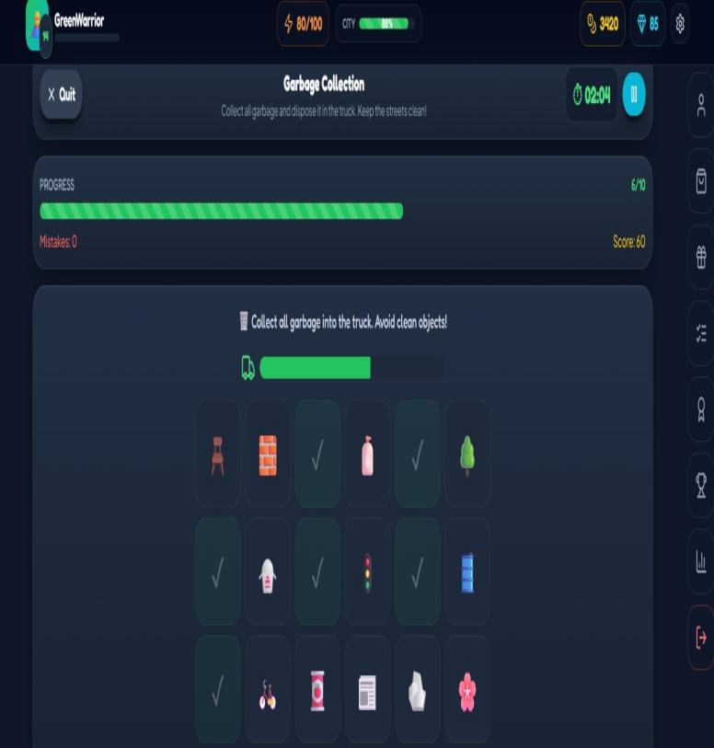

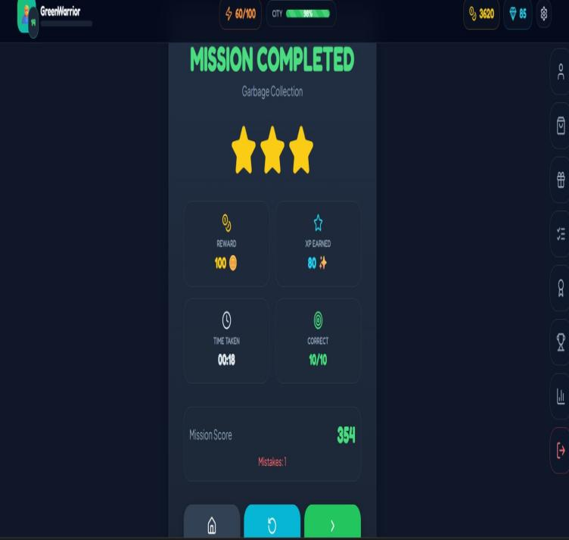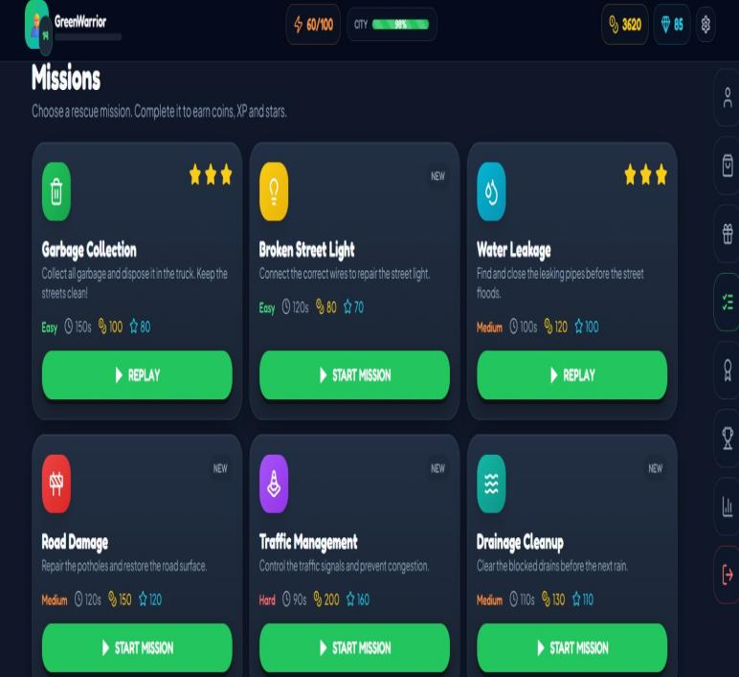
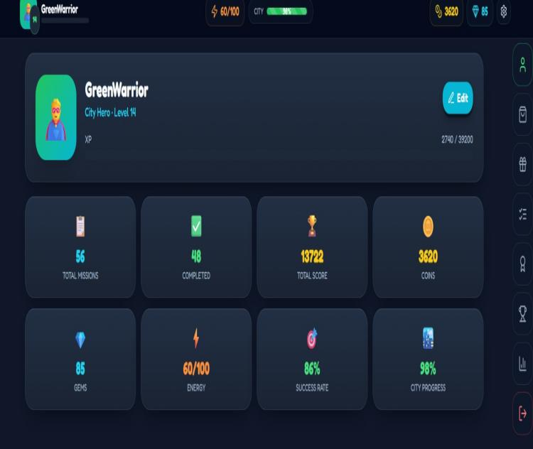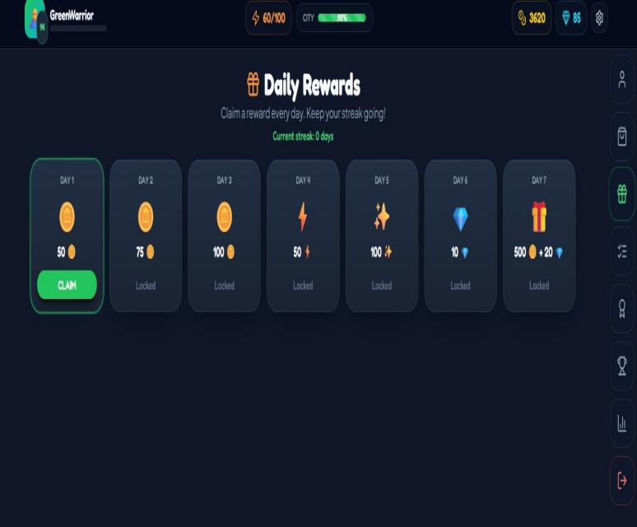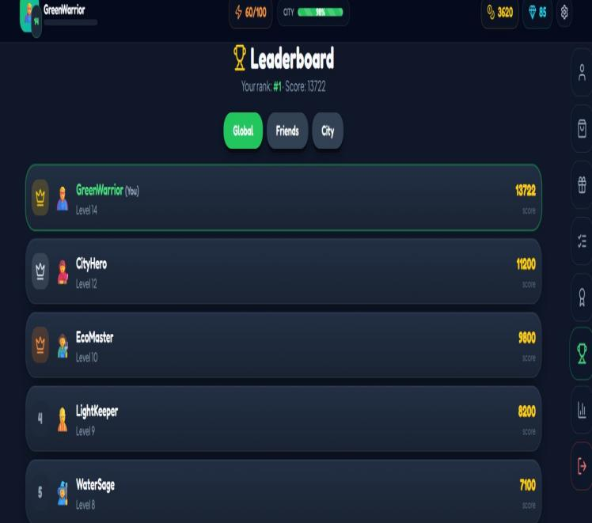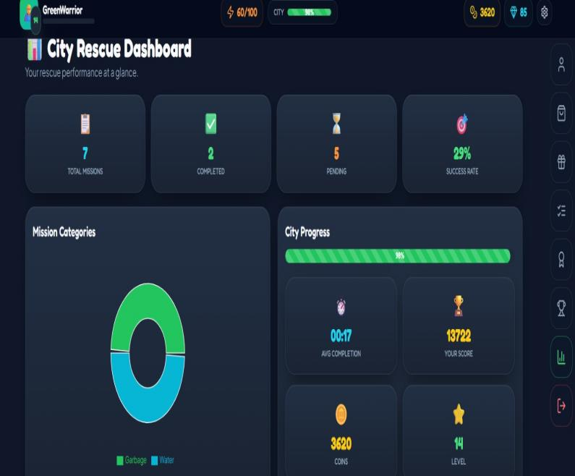

CHAPTER 5
CONCLUSION AND FUTURE SCOPE

5.1 Conclusion
Smart City Rescue is an interactive game-based application developed to create awareness about common urban problems. The project transforms city-related challenges into missions that users can solve through gameplay.
The system provides features such as an interactive city map, missions, mini-games, scoring, rewards, player profiles, achievements, and leaderboards. These features make the learning experience more engaging and encourage users to participate actively.
The project demonstrates how game-based technology can be used to communicate smart-city and environmental concepts in an interactive manner.

5.2 Advantages
The major advantages of the system are:
- Interactive learning experience.
- Simple and user-friendly interface.
- Encourages problem-solving.
- Provides rewards and achievements.
- Improves awareness of urban problems.
- Makes learning more enjoyable.
- Tracks player progress.

5.3 Limitations
The current version may have some limitations:
- The city environment is virtual.
- The number of missions is limited.
- Advanced AI features may require additional development.
- Multiplayer functionality is not included in the initial version.
- Real-time city data is not included.
5.4 Future Scope
The project can be enhanced in several ways:
- Integration with real-time smart-city data.
- AI-based personalized missions.
- Multiplayer mode.
- Real-time multiplayer leaderboard.
- Voice-based interaction.
- More advanced 3D city environments.
- Integration with IoT sensors.
- Real-world waste and traffic datasets.
- Mobile application version.
- More advanced analytics and visualization.
5.5 Final Outcome
The final outcome of the project is an interactive Smart City Rescue game that combines gaming, problem-solving, and smart-city awareness. The system provides a foundation that can be expanded into a larger educational and civic-awareness platform in the future.
Project Link
Smart City Rescue https://smart-city-hero.base44.app

